Possessive Article

Possessive means the owner of something

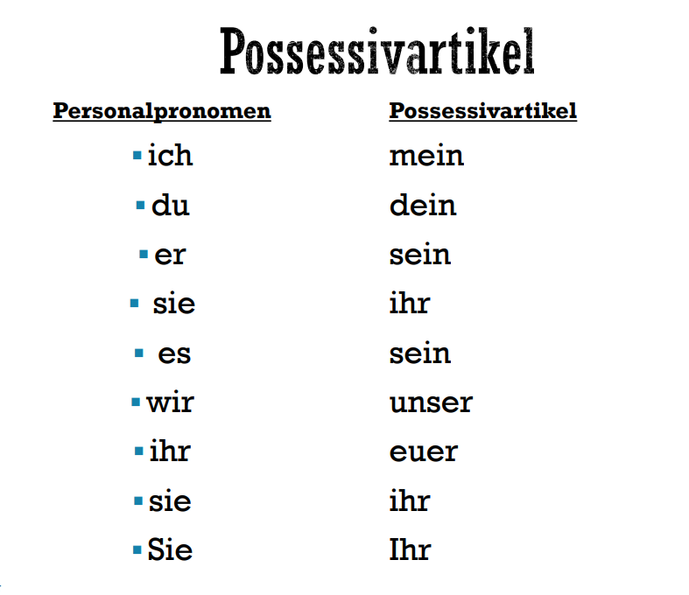

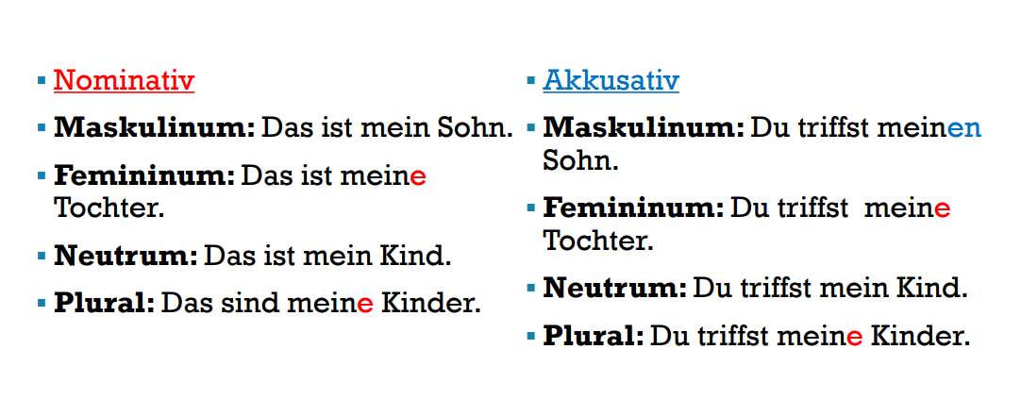

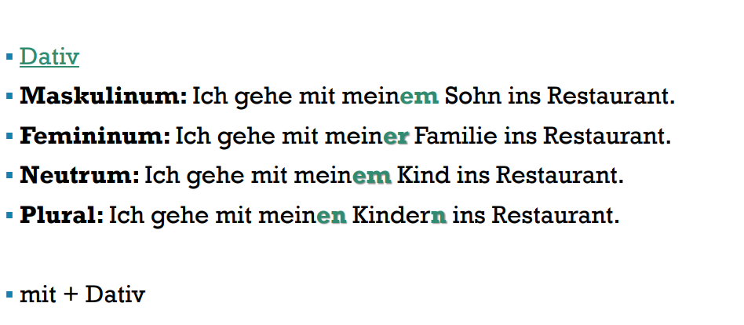

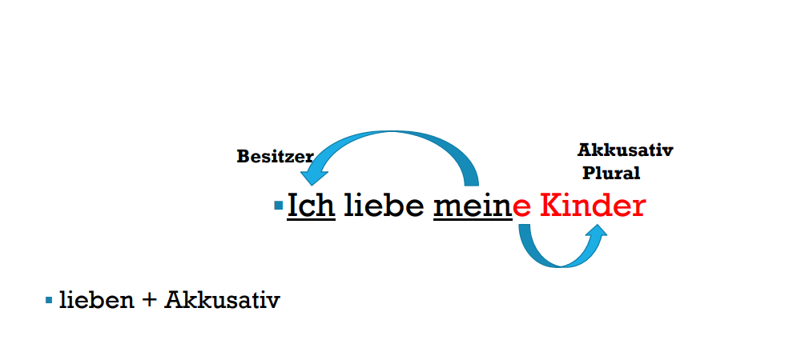

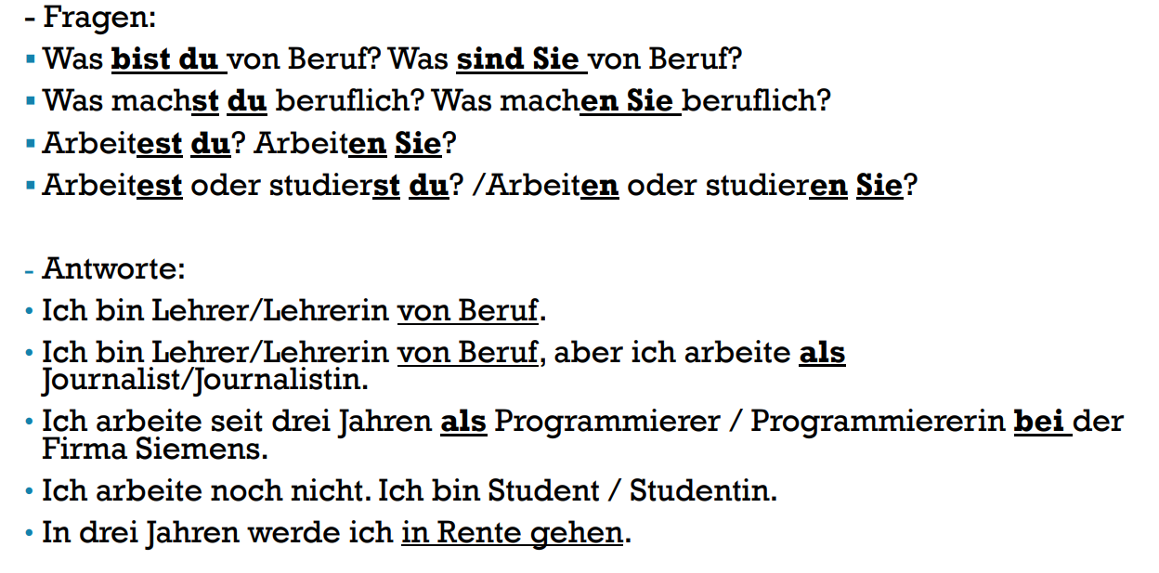

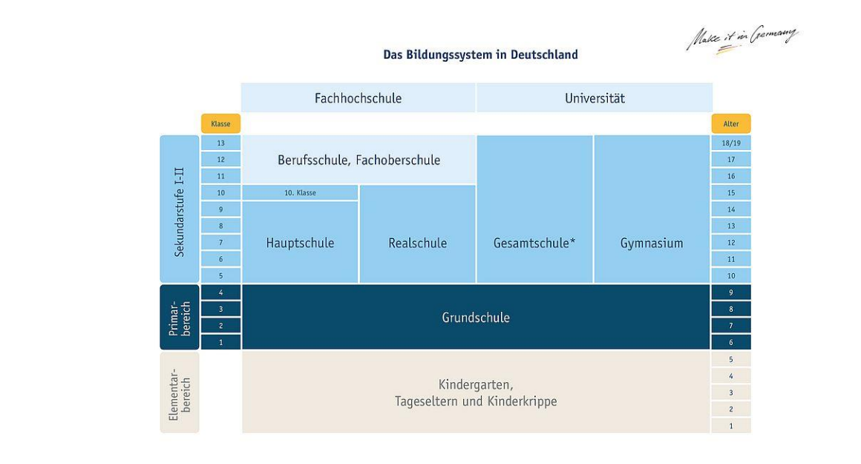

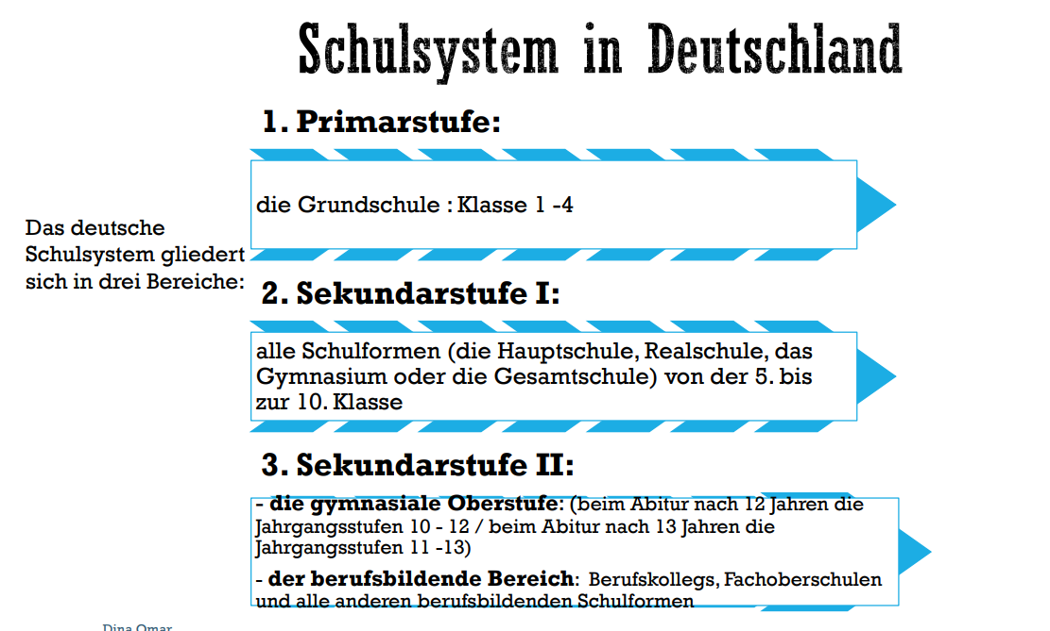

The germans school system is divided in 3 areas

* Primarstufe (primary level)
  + Primary school grade 1-4 (die Grundschule)
* Sekundarstufe (secondary level)
  + All type of school (main school,secondary, high , comprehensive school) from 5 th to 10 grade
* Sekundarstufe 2 (secondary level 2)
  + The upper secondary school level for the arbitur after 12 years, grade 10-12/ for the arbitur after 13 years, grade 11-13
  + Also include the vocational colleges

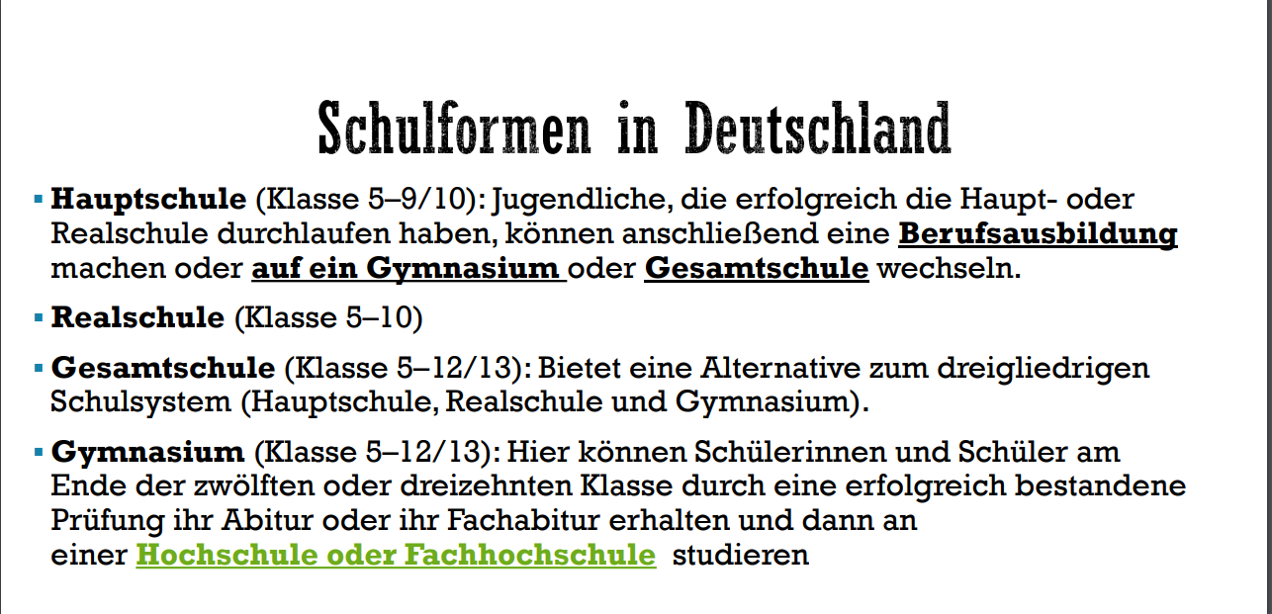

Gefuhle → Feelings

welche Stimmungen drucken die gesichter aus? → What moods do the faces express?

Angry→wutend

Angry → sauer

Angry → Zornig

Annoyed → verärgert

Sad → traurig

Worried → bekummert

Depressed → niedergeschlagen

Surprised → uberrascht

Amazed → erstaunt → verbluffft

Happy → froh → glücklich

Cheerful → frohlich

